**Gordano Sixth Form** Careers Programme Calendar 2021 – 2022

Linked to the Gatsby Careers Guidance Benchmarks (GCGB), the CEIAG programme meets the relevant Careers Development Institute (CDI) framework.

|  |  |  |  |  |  |  |  |  |  |  |  |
| --- | --- | --- | --- | --- | --- | --- | --- | --- | --- | --- | --- |
| **SEPT** | **OCT** | **NOV** | **DEC** | **JAN** | **FEB** | **MAR** | **APR** | **MAY** | **JUN** | **JUL** | **AUG** |

**CAREERS ADVICE & GUIDANCE**

|  |  |  |  |  |  |  |  |  |  |  |  |  |
| --- | --- | --- | --- | --- | --- | --- | --- | --- | --- | --- | --- | --- |
| Careers Advice at Enrolment |  |  |  |  |  |  |  |  |  |  |  |  |
| Careers Guidance Interviews Available by Appointment |  |  |  |  |  |  |  |  |  |  |  |  |
| Fortnightly careers lessons (Y13 Sept – Dec/Y12 Jan – July) |  |  |  |  |  |  |  |  |  |  |  |  |
| 1-1 Guidance interviews offered by UWE upon request |  |  |  |  |  |  |  |  |  |  |  |  |
|  |  |  |  |  |  |  |  |  |  |  |  |  |
|  |  |  |  |  |  |  |  |  |  |  |  |  |

Specialist UWE 1-1 Guidance Interviews on request

|  |  |  |  |  |  |  |  |  |  |  |  |  |
| --- | --- | --- | --- | --- | --- | --- | --- | --- | --- | --- | --- | --- |
| **EMPLOYABILITY: GIVING YOU THE SKILLS EMPLOYERS WANT** | | | | | | | | | | | | |
| Weekly Electives/ Volunteering |  |  |  |  |  |  |  |  |  |  |  |  |
| Employer insights in curriculum subjects |  |  |  |  |  |  |  |  |  |  |  |  |
| Establishing CVs (Y12’s) |  |  |  |  |  |  |  |  |  |  |  |  |
| CV Checks and Updating – upon request |  |  |  |  |  |  |  |  |  |  |  |  |
| National Citizen Service Applications |  |  |  |  |  |  |  |  |  |  |  |  |
| Mock Interviews |  |  |  |  |  |  |  |  |  |  |  |  |
| Work Experience (as part of Futures Week) |  |  |  |  |  |  |  |  |  |  |  |  |
| Assemblies on post-18 options and employer insights |  |  |  |  |  |  |  |  |  |  |  |  |
| Employers insights as part of Science Week |  |  |  |  |  |  |  |  |  |  |  |  |
| ICAEW Business Challenge |  |  |  |  |  |  |  |  |  |  |  |  |
| Mock Assessment Workshops |  |  |  |  |  |  |  |  |  |  |  |  |

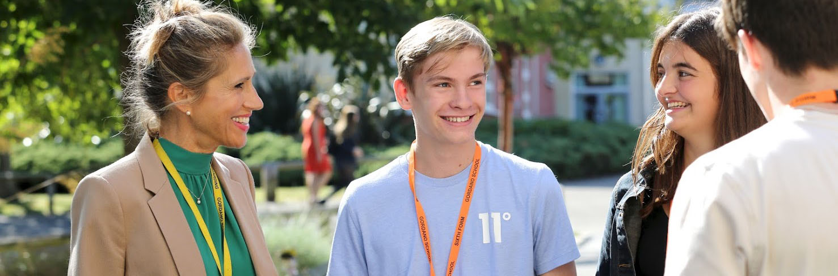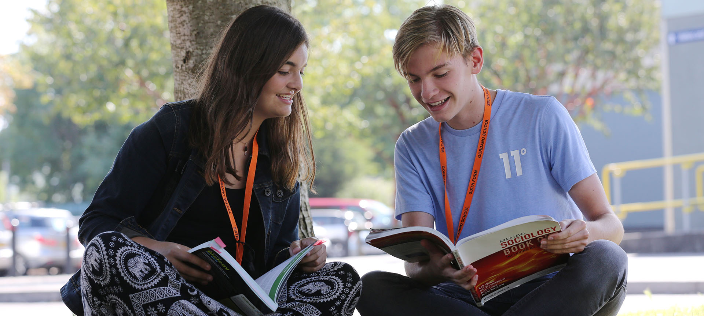

|  |  |  |  |  |  |  |  |  |  |  |  |  |
| --- | --- | --- | --- | --- | --- | --- | --- | --- | --- | --- | --- | --- |
|  | **SEPT** | **OCT** | **NOV** | **DEC** | **JAN** | **FEB** | **MAR** | **APR** | **MAY** | **JUN** | **JUL** | **AUG** |
| **SUPPORT FOR APPLICATIONS TO HIGHER EDUCATION** | | | | | | | | | | | | |
| UCAS Clearing Advice and Support: Drop-ins and Appointments |  |  |  |  |  |  |  |  |  |  |  |  |
| UCAS Application Sessions |  |  |  |  |  |  |  |  |  |  |  |  |
| Support in Writing Effective Personal Statements for UCAS |  |  |  |  |  |  |  |  |  |  |  |  |
| UCAS Application Checking |  |  |  |  |  |  |  |  |  |  |  |  |
| Mock Interviews for HE (including Oxbridge/Medic/Vets) |  |  |  |  |  |  |  |  |  |  |  |  |
| Visit to UCAS Conventions |  |  |  |  |  |  |  |  |  |  |  |  |
| Specialist UCAS Research session offered by UWE |  |  |  |  |  |  |  |  |  |  |  |  |
| Degree Course Advice via 1-1 guidance interviews and drop in |  |  |  |  |  |  |  |  |  |  |  |  |
| Higher Education information Evening |  |  |  |  |  |  |  |  |  |  |  |  |

|  |  |  |  |  |  |  |  |  |  |  |  |  |
| --- | --- | --- | --- | --- | --- | --- | --- | --- | --- | --- | --- | --- |
| **OTHER SERVICES & EVENTS** | | | | | | | | | | | | |
| Post 18 Apprenticeship and School Leaver Evening (including Careers Fair) |  |  |  |  |  |  |  |  |  |  |  |  |
| Careers Convention |  |  |  |  |  |  |  |  |  |  |  |  |
| Themed Teatime Networking Events |  |  |  |  |  |  |  |  |  |  |  |  |
| Keynote Speakers – (including: Chris Packham & Professor Winston) |  |  |  |  |  |  |  |  |  |  |  |  |



**get int o career mode**

**Key Contacts:**

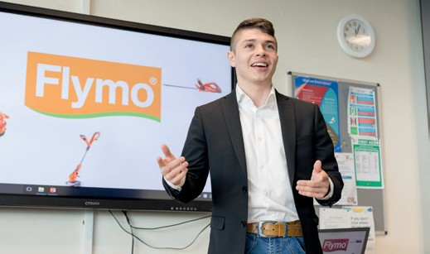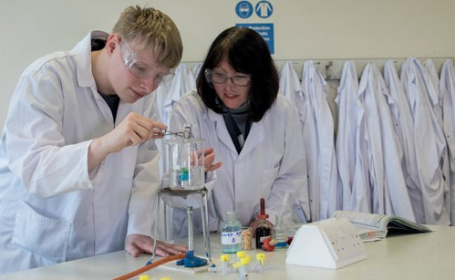

**Assistant Headteacher Jeanne Fairs**

**& Head of Sixth Form** [jfairs@gordanoschool.org.uk](mailto:jfairs@gordanoschool.org.uk)

**Teaching Careers Lead Dr Chris Beer**

[cbeer@gordanoschool.org.uk](mailto:cbeer@gordanoschool.org.uk)

**Careers Adviser Lisa Gardiner** [lgardiner@gordanoschool.org.uk](mailto:jphelps@gordanoschool.org.uk)

**Important Events:**

* **Gordano Careers Convention** Term 1
* **Sixth Form Open Evening** Term 2
* **Teatime Networking** Term 2/3/4
* **National Apprenticeship Week** Term **3**
* **National Careers Week** Term 4
* **Futures Week** Term **6**