**Gordano Main School** Careers Programme Calendar 2021 – 2022

Linked to the Gatsby Careers Guidance Benchmarks (GCGB), the CEIAG programme meets the relevant Careers Development Institute (CDI) framework.

|  |  |  |  |  |  |  |  |  |  |  |  |
| --- | --- | --- | --- | --- | --- | --- | --- | --- | --- | --- | --- |
| **SEPT** | **OCT** | **NOV** | **DEC** | **JAN** | **FEB** | **MAR** | **APR** | **MAY** | **JUN** | **JUL** | **AUG** |

**CAREERS ADVICE & GUIDANCE**

|  |  |  |  |  |  |  |  |  |  |  |  |  |
| --- | --- | --- | --- | --- | --- | --- | --- | --- | --- | --- | --- | --- |
| Careers information ran through Tutor Programme |  |  |  |  |  |  |  |  |  |  |  |  |
| Careers Guidance Interviews Available by Appointment |  |  |  |  |  |  |  |  |  |  |  |  |
| Options Evening – Year 8 |  |  |  |  |  |  |  |  |  |  |  |  |
| Intended Destinations – Year 11 |  |  |  |  |  |  |  |  |  |  |  |  |
| Post 16 Talks – Year 11 |  |  |  |  |  |  |  |  |  |  |  |  |
| Futures ‘Appointments’ |  |  |  |  |  |  |  |  |  |  |  |  |
| Attendance at key events ‘Careers Convention’, 6th Form Open Evenings |  |  |  |  |  |  |  |  |  |  |  |  |

|  |  |  |  |  |  |  |  |  |  |  |  |  |  |
| --- | --- | --- | --- | --- | --- | --- | --- | --- | --- | --- | --- | --- | --- |
| **EMPLOYABILITY: GIVING YOU THE SKILLS EMPLOYERS WANT** | | | | | | | | | | | | | |
| Employer insights in curriculum subjects |  |  |  |  |  |  |  |  |  |  |  |  |
| Establishing CVs (Y10’s) |  |  |  |  |  |  |  |  |  |  |  |  |
| CV Checks and Updating – upon request |  |  |  |  |  |  |  |  |  |  |  |  |
| National Citizenship Service Opportunities |  |  |  |  |  |  |  |  |  |  |  |  |
| Mock Interviews |  |  |  |  |  |  |  |  |  |  |  |  |
| National Careers Week |  |  |  |  |  |  |  |  |  |  |  |  |
| National Apprenticeship Week |  |  |  |  |  |  |  |  |  |  |  |  |
| STEM Week |  |  |  |  |  |  |  |  |  |  |  |  |
| Employers insights (regularly) |  |  |  |  |  |  |  |  |  |  |  |  |

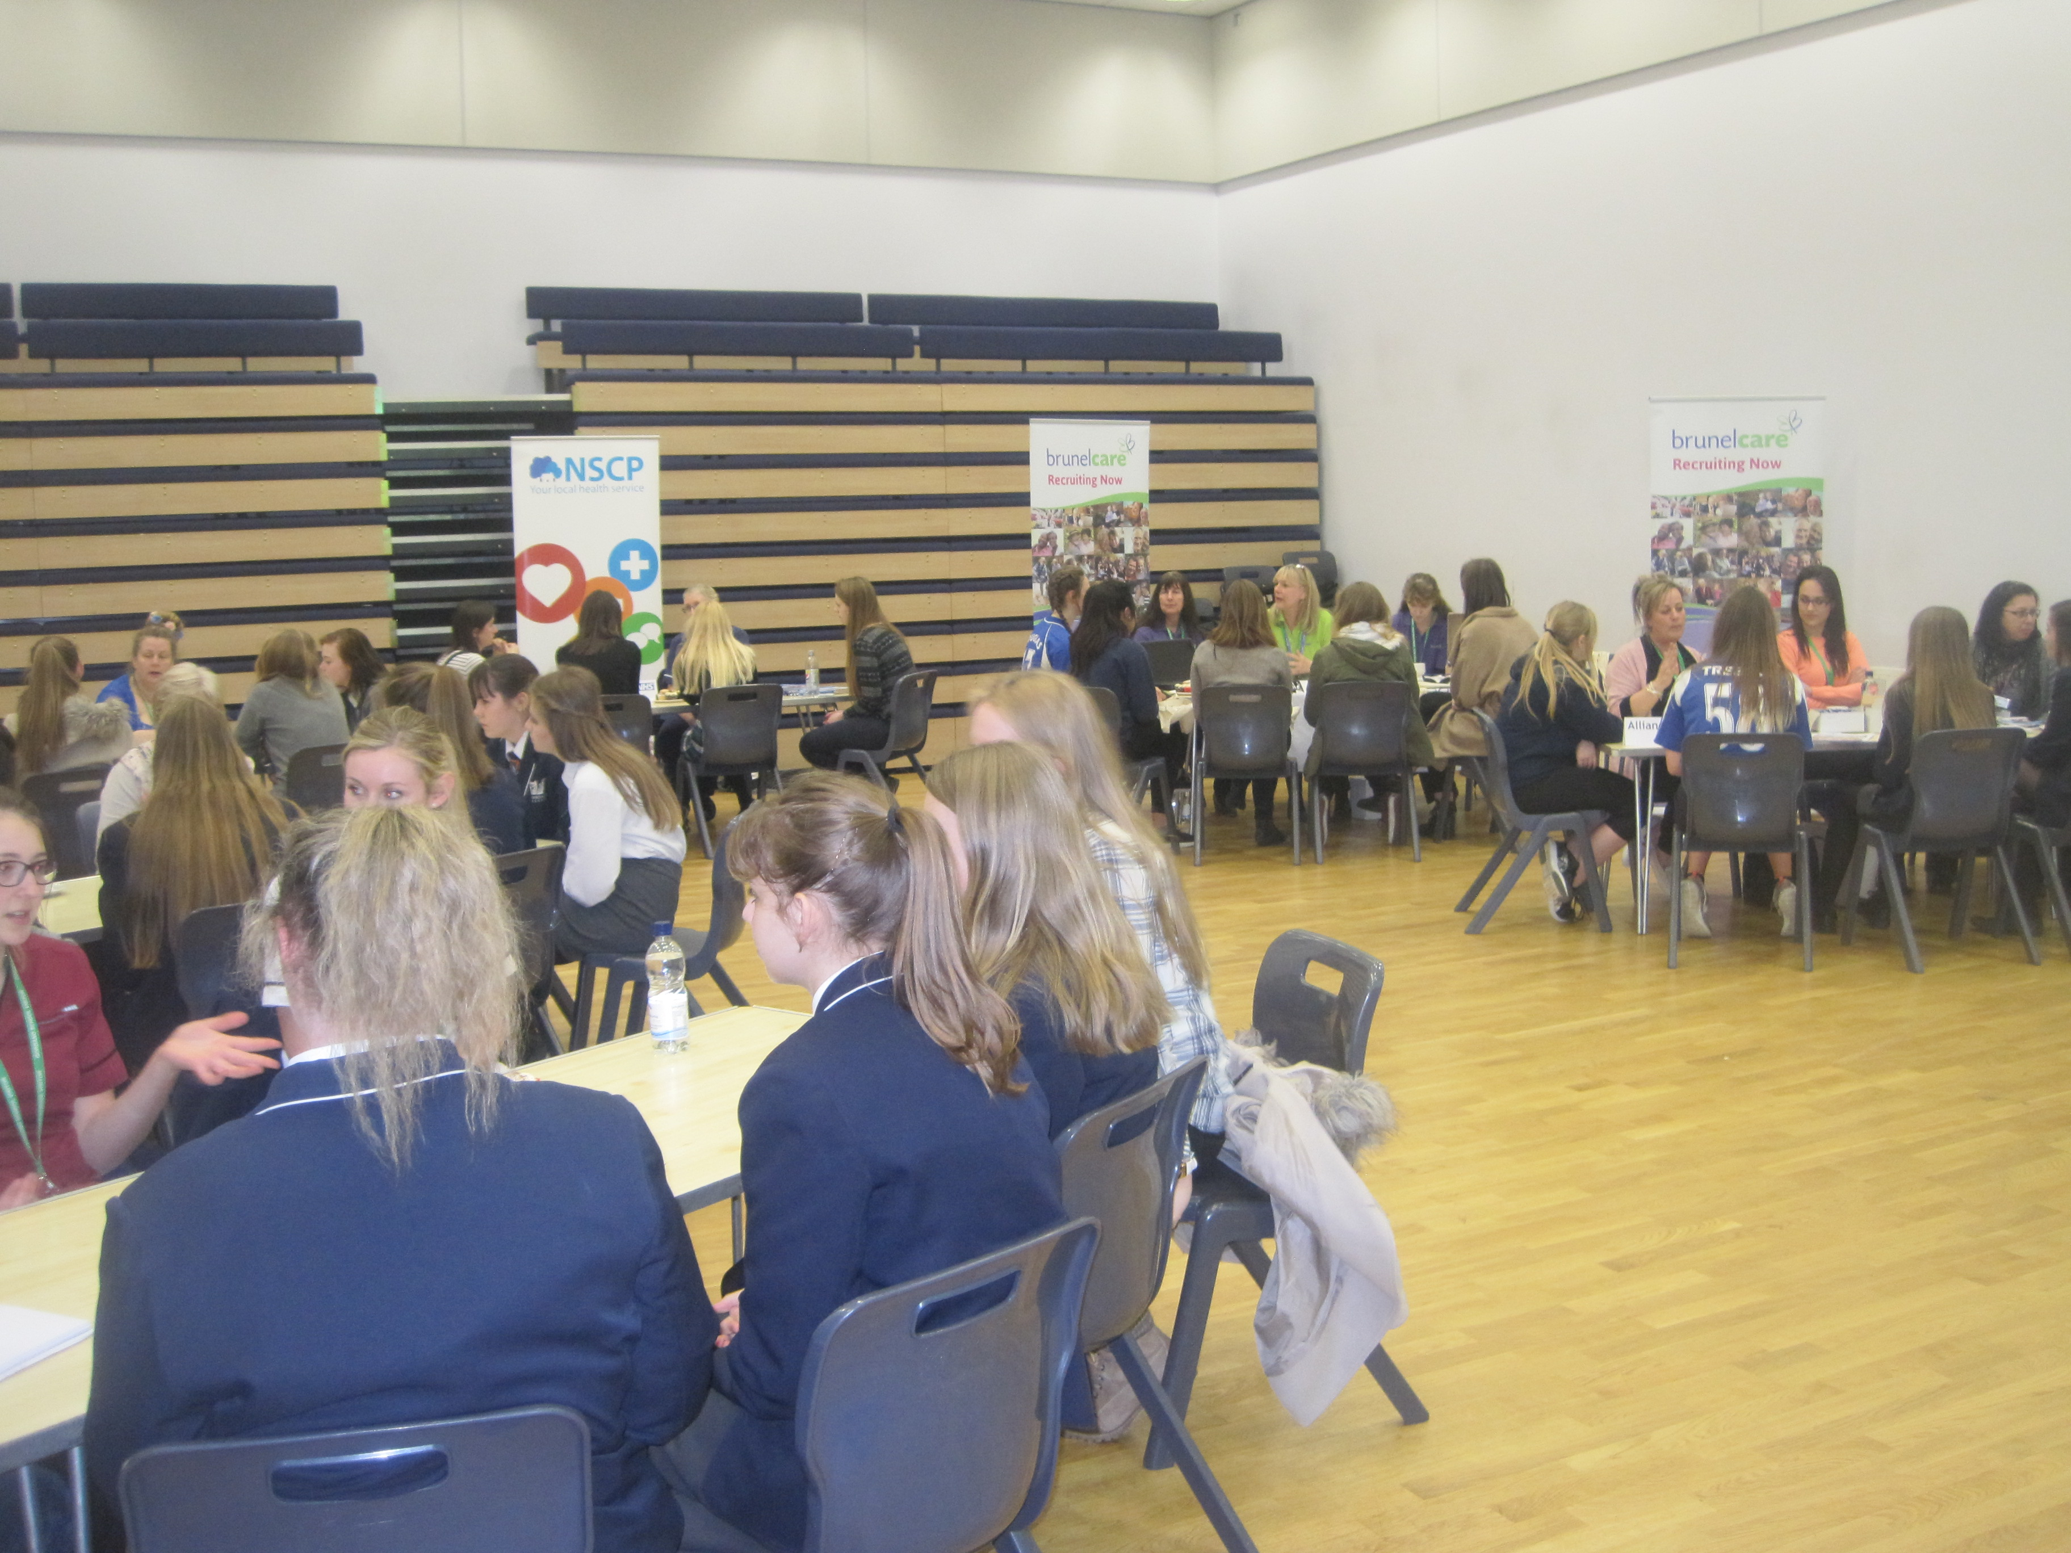



|  |  |  |  |  |  |  |  |  |  |  |  |  |
| --- | --- | --- | --- | --- | --- | --- | --- | --- | --- | --- | --- | --- |
|  | **SEPT** | **OCT** | **NOV** | **DEC** | **JAN** | **FEB** | **MAR** | **APR** | **MAY** | **JUN** | **JUL** | **AUG** |
| **SUPPORT FOR APPLICATION TO POST 16 PROVISION** | | | | | | | | | | | | | |
| Taster Days to Colleges |  |  |  |  |  |  |  |  |  |  |  |  |
| Support in Writing Effective Applications to Colleges & Apprenticeships |  |  |  |  |  |  |  |  |  |  |  |  |
| Mock Interviews for Apprenticeships |  |  |  |  |  |  |  |  |  |  |  |  |

|  |  |  |  |  |  |  |  |  |  |  |  |  |  |
| --- | --- | --- | --- | --- | --- | --- | --- | --- | --- | --- | --- | --- | --- |
| **OTHER SERVICES & EVENTS** | | | | | | | | | | | | | |
| Post 18 Apprenticeship and School Leaver Evening (including Careers Fair) |  |  |  |  |  |  |  |  |  |  |  |  |
| Careers Convention |  |  |  |  |  |  |  |  |  |  |  |  |
| Themed Teatime Networking Events |  |  |  |  |  |  |  |  |  |  |  |  |



**get int o career mode**

**Key Contacts:**

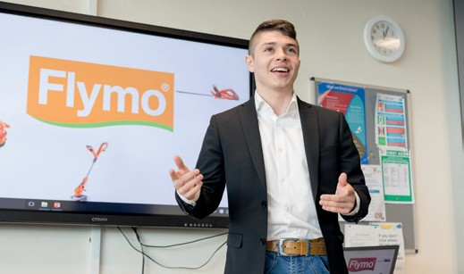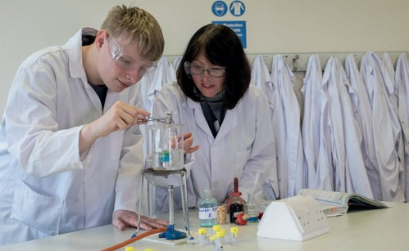

**Assistant Headteacher Jeanne Fairs**

**& Head of Sixth Form** [jfairs@gordanoschool.org.uk](mailto:jfairs@gordanoschool.org.uk)

**Teaching Careers Leads Dr Chris Beer**

[cbeer@gordanoschool.org.uk](mailto:cbeer@gordanoschool.org.uk)

**Careers Adviser Lisa Gardiner** [lgardiner@gordanoschool.org.uk](mailto:jphelps@gordanoschool.org.uk)

**Important Events:**

* **Gordano Careers Convention** Term 1
* **Teatime Networking**  Term 2/3/4
* **Y10 Mock Interview Day** Term **3**
* **National Careers Week** Term 4
* **Y10 Work Experience Week** Term **6**