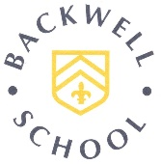**BACKWELL SCHOOL**

**SIXTH FORM CAREERS CALENDAR**

Linked to the Gatsby Careers Guidance Benchmarks (GCGB), the CEIAG programme meets the relevant Careers Development Institute (CDI) framework.

|  |  |  |  |  |  |  |  |  |  |  |  |
| --- | --- | --- | --- | --- | --- | --- | --- | --- | --- | --- | --- |
| **SEPT** | **OCT** | **NOV** | **DEC** | **JAN** | **FEB** | **MAR** | **APR** | **MAY** | **JUN** | **JUL** | **AUG** |

**CAREERS ADVICE & GUIDANCE**

|  |  |  |  |  |  |  |  |  |  |  |  |  |
| --- | --- | --- | --- | --- | --- | --- | --- | --- | --- | --- | --- | --- |
| Careers and Subject Choice Advice at Enrolment |  |  |  |  |  |  |  |  |  |  |  |  |
| Careers Guidance Interviews Available by Appointment |  |  |  |  |  |  |  |  |  |  |  |  |
| Fortnightly careers PSHE lessons |  |  |  |  |  |  |  |  |  |  |  |  |
| Advice and Guidance at Parents’ Evenings |  |  |  |  |  |  |  |  |  |  |  |  |
|  |  |  |  |  |  |  |  |  |  |  |  |  |
|  |  |  |  |  |  |  |  |  |  |  |  |  |

Specialist UWE 1-1 Guidance Interviews on request

|  |  |  |  |  |  |  |  |  |  |  |  |  |
| --- | --- | --- | --- | --- | --- | --- | --- | --- | --- | --- | --- | --- |
| **DEVELOPING EMPLOYABILITY: GIVING STUDENTS THE SKILLS EMPLOYERS WANT** | | | | | | | | | | | | |
| Weekly Careers In…Talks |  |  |  |  |  |  |  |  |  |  |  |  |
| Careers input in curriculum subject areas – speakers, trips, etc |  |  |  |  |  |  |  |  |  |  |  |  |
| Academic research trip to a university library (Y12) |  |  |  |  |  |  |  |  |  |  |  |  |
| CV Checks and Updating – upon request and via Unifrog |  |  |  |  |  |  |  |  |  |  |  |  |
| National Citizen Service Assembly and other Voluntary Groups Opportunities |  |  |  |  |  |  |  |  |  |  |  |  |
| Mock Interviews (Oxbridge) and as needed for other Universities or Employment |  |  |  |  |  |  |  |  |  |  |  |  |
| On-going visiting speakers and workshops developing skills in area such as debating |  |  |  |  |  |  |  |  |  |  |  |  |
| LikeToBe Careers Conferences |  |  |  |  |  |  |  |  |  |  |  |  |
| Support with medical and other work experience placements |  |  |  |  |  |  |  |  |  |  |  |  |
| ICAEW Business Challenge (Y12) |  |  |  |  |  |  |  |  |  |  |  |  |
| Mock Assessment Day Workshops |  |  |  |  |  |  |  |  |  |  |  |  |
| Money workshops on budgeting and managing independent finances |  |  |  |  |  |  |  |  |  |  |  |  |
|  |  |  |  |  |  |  |  |  |  |  |  |  |



|  |  |  |  |  |  |  |  |  |  |  |  |  |
| --- | --- | --- | --- | --- | --- | --- | --- | --- | --- | --- | --- | --- |
|  | **SEPT** | **OCT** | **NOV** | **DEC** | **JAN** | **FEB** | **MAR** | **APR** | **MAY** | **JUN** | **JUL** | **AUG** |
| **SUPPORT FOR APPLICATIONS TO HIGHER EDUCATION AND APPRENTICESHIPS** | | | | | | | | | | | | |
| Visit to Bath University (Y12) |  |  |  |  |  |  |  |  |  |  |  |  |
| UCAS and Apprenticeships Application workshops |  |  |  |  |  |  |  |  |  |  |  |  |
| Assemblies on Apprenticeships and Specialist HE areas such as studying abroad |  |  |  |  |  |  |  |  |  |  |  |  |
| UCAS Application Checking |  |  |  |  |  |  |  |  |  |  |  |  |
| Mock Interviews for HE (including Oxbridge/Medic/Vets) |  |  |  |  |  |  |  |  |  |  |  |  |
| Visit to Careers Fairs: University and Apprenticeships |  |  |  |  |  |  |  |  |  |  |  |  |
| Results Day Support and Advice |  |  |  |  |  |  |  |  |  |  |  |  |
| Degree Course Advice via 1-1 guidance interviews and drop in |  |  |  |  |  |  |  |  |  |  |  |  |
| Post-18 Choices Parents’ information Evening |  |  |  |  |  |  |  |  |  |  |  |  |

|  |  |  |  |  |  |  |  |  |  |  |  |  |
| --- | --- | --- | --- | --- | --- | --- | --- | --- | --- | --- | --- | --- |
| **OTHER SERVICES & EVENTS** | | | | | | | | | | | | |
| Transitions Assembly and Alumni support event |  |  |  |  |  |  |  |  |  |  |  |  |
| Careers Fair – universities, colleges, employers, apprenticeships |  |  |  |  |  |  |  |  |  |  |  |  |
| Weekly Careers In…Talks |  |  |  |  |  |  |  |  |  |  |  |  |
| LSP Conference in partnership with UWE |  |  |  |  |  |  |  |  |  |  |  |  |
| Weekly Careers Bulletin and Apprenticeship Update |  |  |  |  |  |  |  |  |  |  |  |  |



**get int o career mode**

**Key Contacts:**

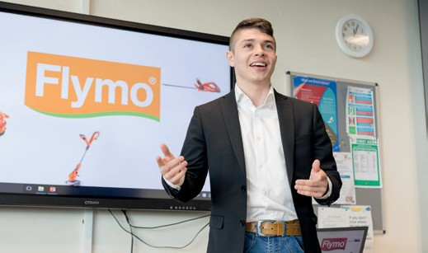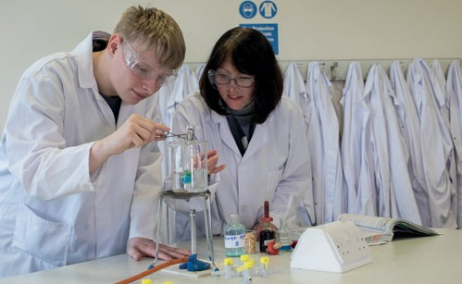

**Assistant Headteacher and Head of Sixth Form**

Rose Haywood

rhaywood@backwellschool.net

**Careers Adviser and Coordinator**

Charlotte Ball

cball@backwellschool.net

**Important Dates:**

* **Sixth Form Open Evening** 14th November 2019
* **National Apprenticeship Week** 3rd – 7th February 2020
* **Backwell Careers Fair** 27th February 2020
* **National Careers Week** 2nd – 7th March 2020
* **LSP Enterprise Conference 6** May 2020